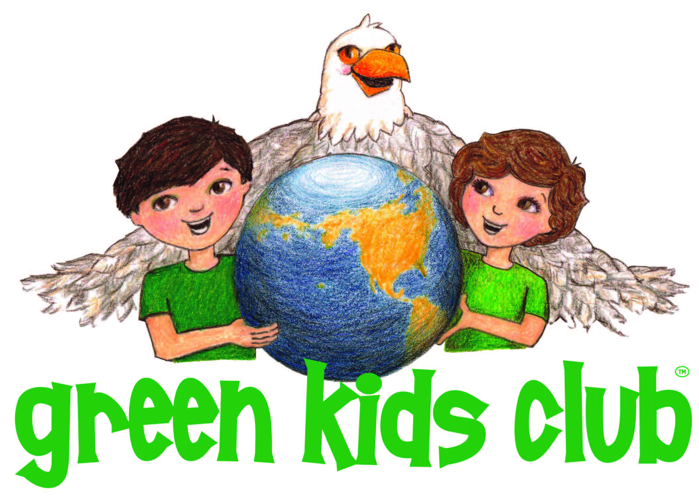

GREEN KIDS CLUB Visits Botswana & Promotes New Book
“The African Bush Fire & the Elephant”

2016 Winner of Dr. Toy’s Best Green Company Award

(FOR IMMEDIATE RELEASE–January 7, 2017–Idaho Falls, ID)– Idaho-based Green Kids Club (GKC), Inc. visited Kasane, Botswana in September 2016 to attend the annual Global March for Elephants, Rhinos, & Elephants and present their new book, “The African Bush Fire & the Elephant.”

GKC, Sylvia Medina co-authored a book with Kelly Landen, Program Manager for Elephants Without Borders in conjunction with the Department of Forestry & Range Resources of Botswana. The book highlights issues related to bush fires and impacts to wildlife. It primarily focuses on how bush fires are started, mainly by poachers in efforts to drive wildlife for the taking. Other issues addressed in the book include, ensuring children in an impacted area remain safe during the wildfires. The book brings forward how fire impacts the ecosystem and all inhabitants of the region and how one can make a difference to prevent these fires.

In addition, Green Kids spent time with children from 14 schools from the Kasane region that participated in the Chobe District Environmental Fair. Here, Sylvia Medina was a guest speaker for the children. She also supported the event by providing her new book, The African Bush Fire & the Elephant, as an award to the children who participated. To highlight the visit, Green Kids participated in the Elephant’s Without Borders “We are Proud of our Natural Heritage” parade – which is part of the International Global March for Elephants, Rhinos & Lions. At the end of the March, Green Kids with Elephants Without Borders was proud to be able to present their book to the Dept. of Forestry & Range Resources, accepted by Tawana Maunganidze.

Green Kids plans to continue supporting Elephants without Borders and the people of Botswana in combating poaching and environmental issues.

About Green Kids Club:

Founded by Sylvia Medina, Green Kids Club writes and illustrates stories related to environmental stewardship, and management of animal ecoystems. The books are based on children (the Green Kids) who drink water from a magic spring and obtain the powers to communicate with animals. Green Kids Club stories takes on difficult environmental situations such as habitat encroachment, drought issues, endangered species and poaching as some examples. Stories entail environmental adventure and helping the animals.
www.greenkidsclub.com

About Elephants Without Borders:

Elephants Without Borders (EWB) is a charitable organization dedicated to conserving wildlife and natural resources; through innovative research, education, and information sharing with all its people, they strive to encourage mankind to live in harmony with wildlife and the natural world. EWB’s vision is to open borders for Africa’s wildlife through research and education, and to help ensure a prosperous and compatible future between people and wildlife.
http://elephantswithoutborders.org/

